

Vidyavardhini’s College of Engineering & Technology

Department of Artificial Intelligence and Data Science (AI&DS)

|  |  |
| --- | --- |
| **Name:** | Vinith Shetty |
| **Roll No:** | 55 |
| **Class/Sem:** | SE/IV |
| **Experiment No.:** | 2B |
| **Title:** | Program for calculating factorial using assembly language |
| **Date of Performance:** | 30/01/2024 |
| **Date of Submission:** | 06/02/2024 |
| **Marks:** |  |
| **Sign of Faculty:** |  |

Vidyavardhini’s College of Engineering & Technology



Department of Artificial Intelligence and Data Science (AI&DS)

**Aim:** Program to calculate the Factorial of a number.

**Theory:**

To calculate the factorial of any number, we use MUL instruction. Here, initially, we initialize the first register by value 1. The second register is initialized by the value of the second register. After multiplication, decrement the value of the second register and repeat the multiplying step till the second register value becomes zero. The result is stored in the first register.

Algorithm:

1. Start.
2. Set AX=01H, and BX with the value whose factorial we want to find.
3. Multiply AX and BX.
4. Decrement BX=BX-1.
5. Repeat steps 3 and 4 till BX=0.
6. Stop.

Code:

ORG 100H

MOV AX, 00H

MOV BX, 04H

MOV CX, 02H

L1: ADD AX, BX

DEC CX

JNZ L1

RET

Vidyavardhini’s College of Engineering & Technology



Department of Artificial Intelligence and Data Science (AI&DS)

Output:-

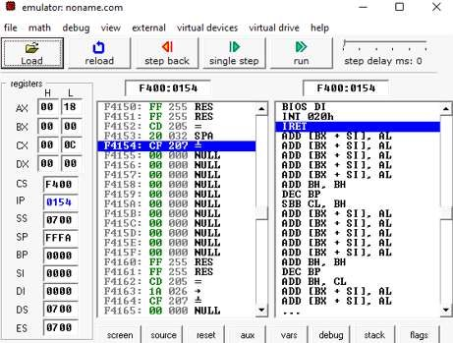

Vidyavardhini’s College of Engineering & Technology



Department of Artificial Intelligence and Data Science (AI&DS)

Flowchart:

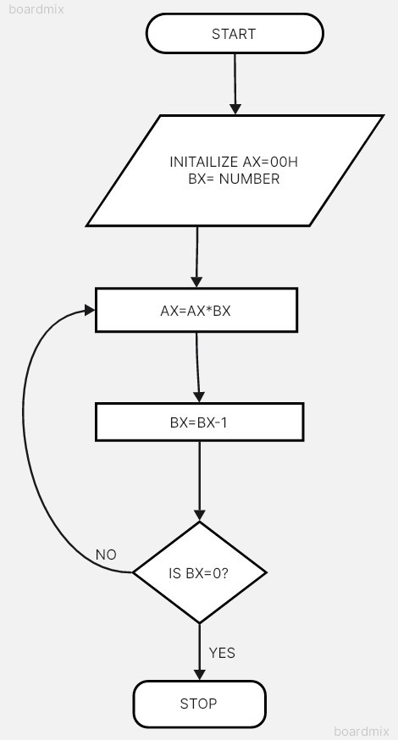

Vidyavardhini’s College of Engineering & Technology



Department of Artificial Intelligence and Data Science (AI&DS)

Conclusion:

* 1. Explain shift instructions.
  2. Explain rotate instructions.

1)The 8086 can perform two types of Shift operations; the logical shift and the arithmetic shift. There are four shift operations (SHL, SAL, SHR, and SAR).

2)The 8086 can perform two types of rotate operations; the rotate without carry and the rotate through carry. There are four rotate operations (ROL, ROR, RCL, and RCR). ROL shifts each bit of a register to the left. The highest bit is copied into both the Carry flag and into the lowest bit of the register